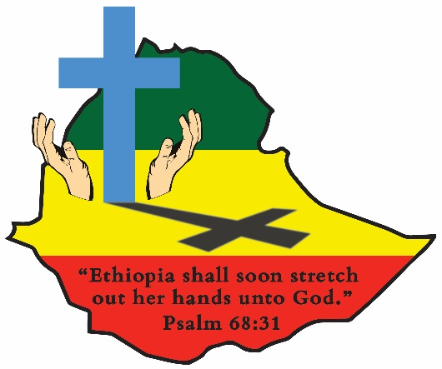
ETHIOPIA GOSPEL OUTREACH
Woodward Park Church of Christ
P.O. Box 3836, Pinedale, CA 93650
559 446-2550
February 23, 2022

CHANGE OF ADDRESS EXPLANATION: Perhaps you have noticed our mailing address has changed. Some have asked why. The reason was the uncertainty caused by Covid and having office staff quarantined and with a volunteer staff at times who are unaware of what to do with your incoming mail, we felt the necessity of keeping the Ethiopia Mission mail protected; therefore, we have a new box number. Pinedale is a small incorporated area in north central Fresno where the Post Office is located. Everything is the same; nothing has changed except the mailing address. Thank you for your interest concerning the change.

NEW ADDITIONS TO THE CHURCH IN ADDIS ABABA:
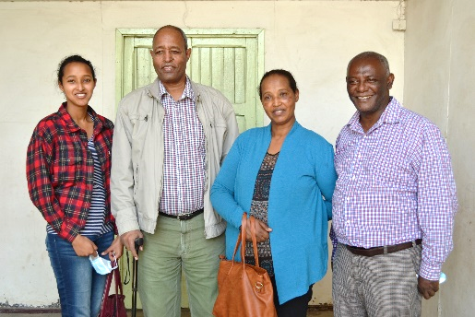
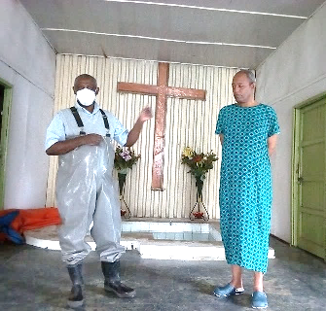

In our August 2020 newsletter, we reported the conversion and baptism of Belay Lemma. On the left, Brother Moges is seen taking Belay’s confession before his emersion into Christ. Belay had always been a “seeker of truth” and Moges had spent three hours each week with him for 18 months prior to his obedience. Because of Covid at that time, Belay invited Moges and his family to worship with him in his home. Since that time Belay and Moges have continued to study God’s word with Belay’s family and on January 31st Belay’s wife, Ehete, and daughter Yimima, decided to obey the gospel and be added to the body of Christ in Addis Ababa. They are pictured as Moges accepts their confession. On the right is the new Belay Lemma Christian family.
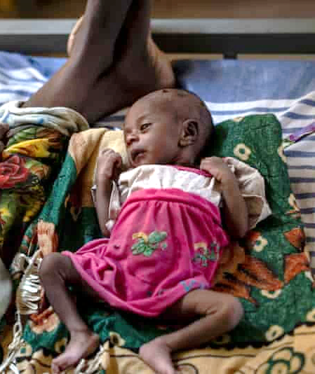
ETHIOPIA FAMINE NEWS:
Google news today is filled with warnings about the drought and famine in Ethiopia. The picture on the right was taken by Ben Curtis/AP recently. It causes us to remember the 80’s when millions of Ethiopians died from starvation and disease. According to the government, the drought is affecting the eastern and southern parts of the country. We are very concerned about the Borana region where we have many brethren who are suffering.
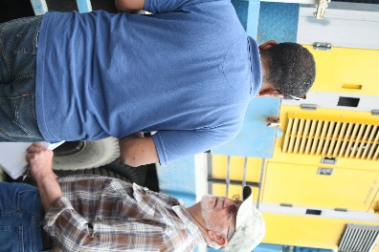
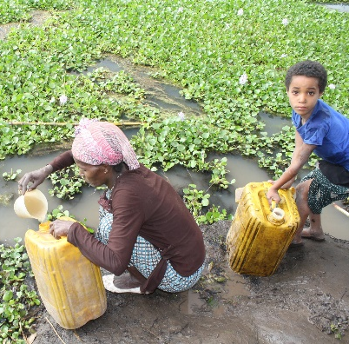
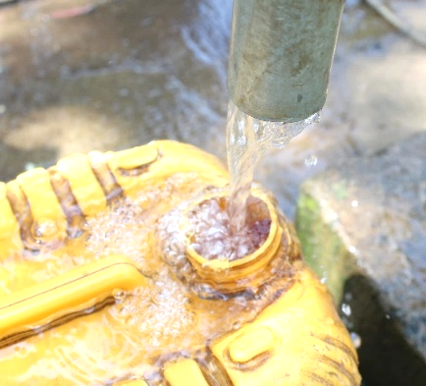
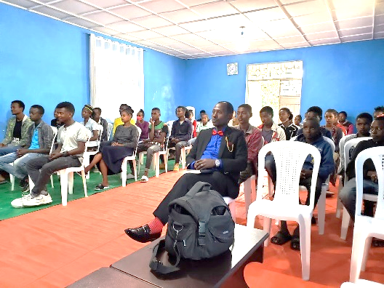
MORNING CHAPEL TIME AT THE HAWASSA MIDDLE SCHOOL FOR THE DEAF:
The fear of Covid is still plaguing Ethiopia. However, the government understands the value of all students attending school. Our five Schools for the Deaf are open. At our Hawassa Middle School we only have a morning session because of the smaller student body. The larger schools split into morning and afternoon sessions. The work is being accomplished and the children are still being taught about God’s love for them.
THE WATER WELL PROJECT BEGINS A NEW DRILLING SEASON FOR 2022:
During the last drilling season the crew, with God’s blessing, completed fifty new producing wells in the Badewatcho, Kambatta, and Sidama areas. Last month the Regional Water Bureau signed a new agreement with us to drill 20 new wells in the Sidama District. At this writing the crew is in the field drilling. They hope to complete the 20 wells by the end of March. Last year after the first 20 were completed in record time, the Water Bureau signed an ammendment with us for 20 additional wells. Our prayer is they will do the same this round. They are very aware of the massive need for pure clean water for their people. The pictures above illustrate both a traditional rain water collection pond that is used for drinking water and the pure clean water that comes from the wells we complete. An amazing life saving difference!! On the right, Bro. Monte Hininger is shown discussing with an in-country well driller concerning the use of his India built drilling rig. We hope to place an order for a new rig very soon. We will keep you informed.
PRAYER REQUEST FOR TWO FAITHFUL GOSPEL PREACHERS AND LEADERS:
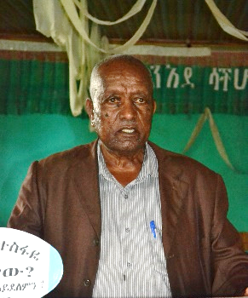
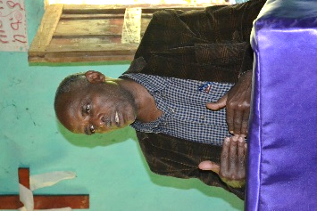
Brothers Walde Ghorghis, left, and Tesfaye Bogale, right, are both receiving treatment for cancer. Both have had surgery and are now undergoing some type of chemo treatment. Walde has been a preacher since 1968 and serves as the director of the Jajura School of Preaching. Tesfaye served as a preacher and as the director of the Santariea School of Preaching since 1991 and has been involved in planting many churches in the Sidama Region. Please pray for their complete recovery. Our constant prayer is that God will continue to bless you all.
Kevin and John Ed Clark

