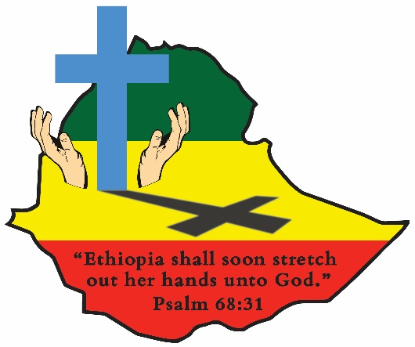
ETHIOPIA GOSPEL OUTREACH
Woodward Park Church of Christ
P.O. Box 3836, Pinedale, CA 93650
559 446-2550

January 26, 2023

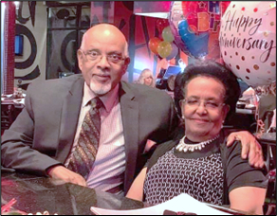
BEHAILU AND ALEM ARE MOVING BACK TO ETHIOPIA IN JANUARY:
Behailu and Alem will be returning to their homeland of Ethiopia on January 31st. This has been their dream for the past several years. Both said they want to spend the rest of their lives ministering to their people, teaching the gospel to the lost, mentoring young men and women, and edifying the church in their own country. Their ministry started in 1965 and wherever they lived they were totally committed to serving the Lord and His church. All the brethren in Ethiopia will be very excited to have them back. In talking with Behailu, he indicated their health is good and they plan to return to Seattle once each year for their regular yearly medical checkups. Three of their children live in the Seattle area and one (Daniel) lives in Ethiopia. With the new two-year Preacher Training School starting in a few months, Behailu will be a welcome addition to the teaching staff. In the past six or so years, Behailu has translated all of the Sunset International Bible Institute lesson material into the Amharic language, and it is available to use in the new school in Addis Ababa. Our prayer for Behailu and Alem is that God will give them many more years of active service in His Kingdom. We ask all of you to pray for them as they make this very important move. (The picture was taken at the celebration of their 56th wedding anniversary last year)

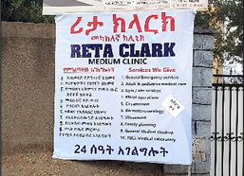
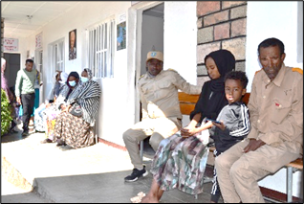
MEDICAL CLINIC AVERAGING 85 TO 130 PATIENTS EACH DAY:

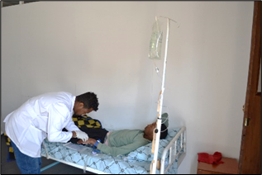
The medical clinic on the compound in Addis Ababa is packed with patients every day. It is staffed with three doctors and a well-trained staff. It provides a blessing for the people in the Makanissa area of the city as there are few well equipped clinics like this one available. God has blessed us with this great opportunity to serve the people.

WORLD BIBLE SCHOOL CONVERSION IN DIRE DAWA:
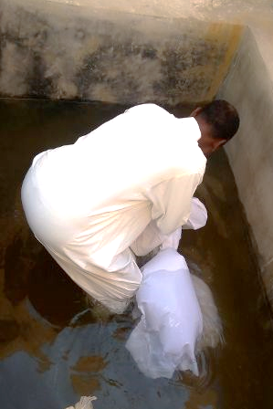
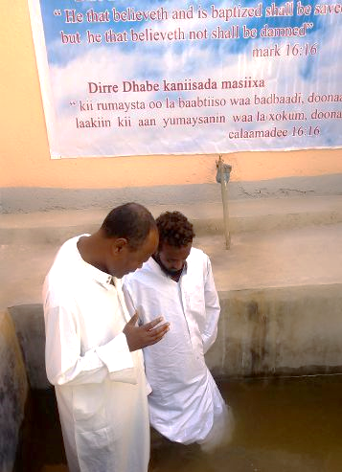
Report from Belay Kebede:
“Firomsa Mohammad completed the Oromo language World Bible School lessons. He was convicted by God’s word and expressed his desire to be born again through baptism for the forgiveness of his sins. His father, and mother, and his two brothers also studied the gospel, and they are In the process and will soon obey. I built this baptism pool in my compound because of the lack of water throughout the area. The rivers around Dire Dawa are all dry. Now praise the Lord, we have our own baptistery pool. Let all the glory, honor, and thanks be to our Lord. Please pray with us for Firomsa and his Family. God Bless you all.” Belay (Note also that Dire Dawa is a Muslim populated area and it is dangerous for those being baptized and for the one doing the baptizing in public pools or rivers. Now the church in Dire Dawa has a private baptistry to baptize those convicted by the gospel message. JEC)

BRO. DEMISSIE ROMA ASSIGNED TO PREACH IN JIMMA:

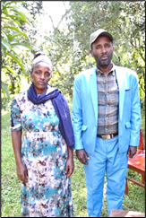
A new congregation has been established in the city of Jimma. The first congregation is on the compound of our Kindergarten in the city. Brother Getachew, a professor at the Addis Ababa University and a member of the Addis Ababa Church of Christ, was transferred to a position at the University of Ethiopia in Jimma. He along with another brother who was a medical doctor wanted to plant a new church more in the center of the town. They approached Habtu and asked if there was a preacher who could come and work with them for a year or so and with the help of Bros. Tesfaye and Seyum, Demissie Roma was selected. Demise has been one of the instructors at the School of Preaching in Santariea for many years. Over the years he has been involved in planting other congregations and then helping to build them up. Jimma is in a Muslim area and Demissie will be very effective in working among them. His father, Brother Roma, was killed because of his faith during the years Ethiopia was occupied by the Communist ideology. Please pray for the success of this new outreach in a difficult area.

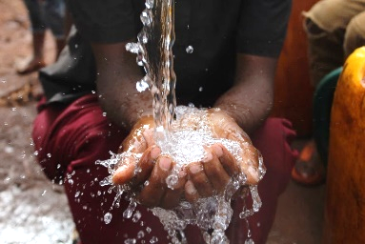
UPDATE ON THE WATER DRILLING PROJECT AND THE NEW RIG:
The authenticated documents have finally been completed by the U.S. Department of State and are in Ethiopia. We believe a “duty free” permit will soon be issued for us to get the new rig out of customs and be ready to start drilling on a new 60 well agreement being processed at the Water Bureau. There is still some unrest in the Hawassa area, but it is improving.

The feeding program is still going on in the Dawro area with the funds you have provided. God is blessing the work in Ethiopia. Thanks to all of you who faithfully pray for and support all the ministries of this great work. Kevin and John Ed Clark

