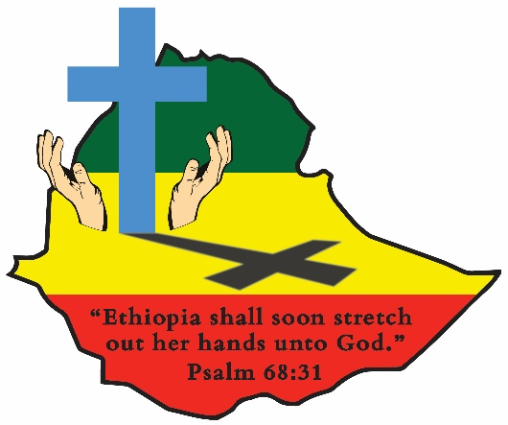
ETHIOPIA GOSPEL OUTREACH
Woodward Park Church of Christ
P.O. Box 3836 Pinedale, CA 93650
559 446-2550

January 26, 2022
TRIP REPORT FROM BROTHER BEHAILU:
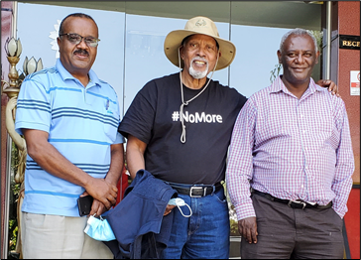
Brothers Alemayehu, left and Moges, right accompanied Behailu on a trip to the southern region to visit brethren, churches, schools of preaching, schools for the deaf, kindergartens and to conduct bible seminars everywhere they visited. They are pictured here as they stopped in the town of Butajira for breakfast. This town is located about half-way between Addis Ababa and Hosana, their destination for that day.
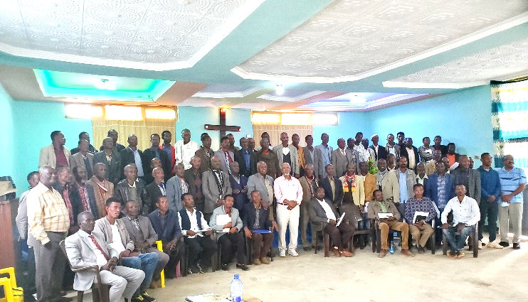
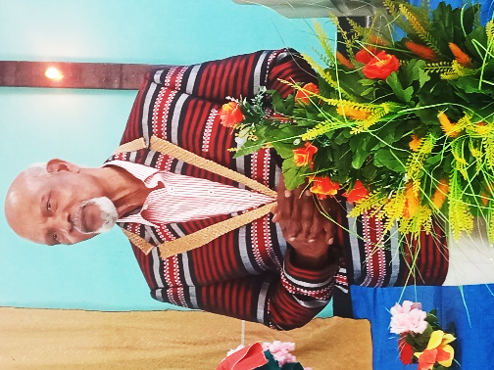
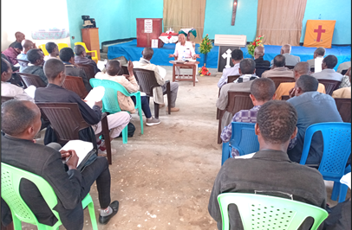
THE FIRST PREACHERS CONFERENCE WAS HELD AT THE HOSANA CHURCH:
Behailu reported they had intended to go to the School of Preaching in Jajura but the brethren in the area knew the road to Jajura wasn’t good so they had already planned to conduct the conference in Hosana. Pictured above on the top left are pictured many of the 90 participants. This is by far the largest gathering of preachers since the Covid pandemic started in 2020. Above on the top right, Behailu is pictured teaching. These brethren had come from many different areas and congregations. They came by bus and on trucks and some walked three to four hours to get there. Behailu taught for several hours on the subject of “Leadership in the Church” and the need for elders in every congregation. Many preachers promised they would concentrate on preparing men to serve as elders in their local churches. At the end of the seminar the brethren presented Behailu with a new “coat of many colors”. It was an emotional moment for Behailu.
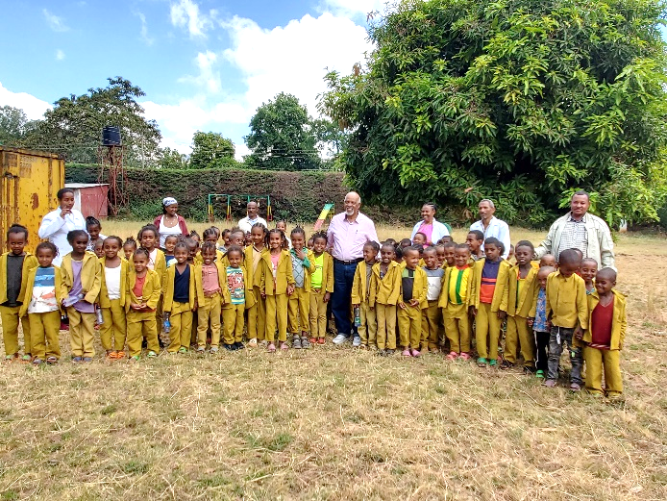
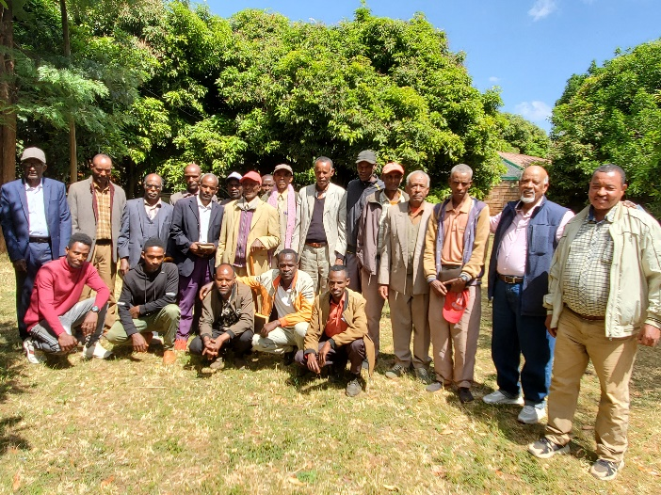
THE SECOND CONFERENCE WAS HELD AT THE SHINCHICHO KINDERGARTEN The following day preachers from the Kambatta District gathered at the Shinshicho Kindergarten for an afternoon seminar. The study started at 11:00 and dismissed at 4:30. There was a lot of excitement among the brethren because this was the first time some of them had seen Brother Behailu in several years. The afternoon session at the kindergarten posed with Behailu on the right. This was their first time to be with him. Everyone was blessed and encouraged.
We will have additional news from Behailu’s visits in Shone, Mazoria, Hawassa and Santariea for next month’s newsletter. Many great things are happening!!
TAKING TIME FOR CORRESPONDENCE COURSE STUDENTS:
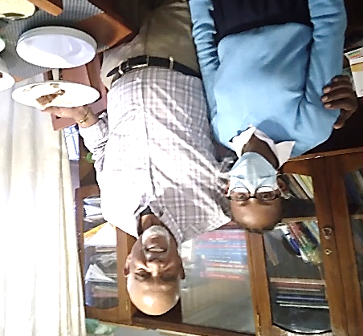
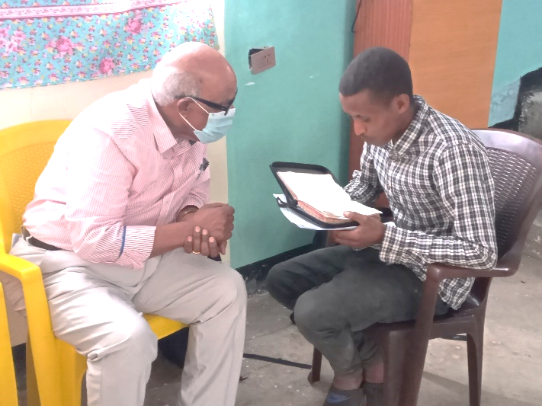
Even with Behailu’s busy schedule, time was taken to study one on one with a World Bible School student. Behailu has always been a big promoter of the WBS ministry. The courses have introduced many people to Christ and to the gospel. For all of you who are WBS teachers, please know your ministry is eternally important and reaches people who may never otherwise be reached with the saving message of Jesus. This young man had studied the Amharic WBS courses.
A World English Institute Bible Correspondence course teacher from the Springbrook Church of Christ in Renton, WA (Behailu’s home church) had given Behailu the name of a student he was teaching in Addis Ababa. Behailu and two other brethren went to her home to meet her and her family and were treated to a great meal and a time of fellowship. Her name is Lilly and she said she became a WEI student because of Covid!! She couldn’t attend public school, so she was looking online and found the WEI website and signed up for the lessons. Behailu has great hope for her and the four members of her family. Thanks to all of you who pray for and faithfully support these great ministries in Ethiopia. May God bless you all! Kevin and John Ed Clark

